**WORKSHEET** **3** **SQL**

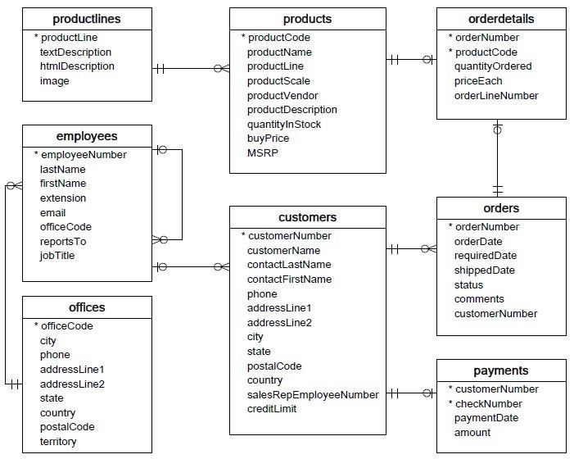

1. Write SQL query to create table Customer

Ans)

CREATE TABLE Customer (  
    customerNumber int,

customerName varchar(200),  
    ContactlastName varchar(200),

ContactFirstName varchar(200),

Phone int,

addressLine1 varchar(200),,

addressLine2 varchar(200),,

city varchar(50),

state varchar(50),

postalCode int,

country int ,

salesRepEmployeesNumber int ,

creditLimit int);

2. Write SQL query to create table Orders.

Create a table Orders(

orderNumber int,

orderDtae DATE,

requiredDate DATE,

shippedDate DATE,

status varchar(50),

comments varchar(200),

customerNumber int);

3. Write SQL query to show all the columns data from the Orders Table

Selct * from Orders;

4. Write SQL query to show all the comments from the OrdersTable.

Select comments from Orders;

5. Write a SQL query to show orderDate and Total number of orders placed on that date, from Orderstable.

Select orderDate ,count(orderNumber) AS Total_number from Orders ;

6. Write a SQL query to show employeNumber, lastName, firstName of all the employees from employees table

Select employeNumber, lastName, firstName from employees;

7. Write a SQL query to show all orderNumber, customerName of the person who placed the respective order

Select O.orderNumber, C.customerName from orders AS O JOIN customers AS C

ON O.cutomerNumber=C.customerNumber ;

8. Write a SQL query to show name of all the customers in one column and salerepemployee name inanother column.

Select C.customerName,(E.firstName+’ ‘+E.lastName)as salerepemployee_Name from customers AS C LEFT JOIN employees AS E ON C.salesRepEmployeeNumber=E.employeeNumber ;

9. Write a SQL query to show Date in one column and total payment amount of the payments made on that date from the payments table.

Select paymentDate ,sum(amount) from payments groupby paymentDate;

10. Write a SQL query to show all the products productName, MSRP, productDescription from the products table

Select productName, MSRP, productDescription from products;

11. Write a SQL query to print the productName, productDescription of the most ordered product.

Select productName, productDescription from products group by count(productName ) As ordersno orderby ordersno Desc limit 1;

12. Write a SQL query to print the city name where maximum number of orders were placed

Select C.city, count(O.orderNumber) from customers As C join orders As O ON C.customerNumber=O.cutomerNumber orderby count(O.orderNumber) DESC limit 1

13. Write a SQL query to get the name of the state having maximum number of customers.

Select max(customerNumber) from customers groupby (state) limit 1;

14. Write a SQL query to print the employee number in one column and Full name of the employee in the second column for all the employees.

Select employeeNumber ,(firstName+’ ‘+lastName)as fullName from employees ;

15. Write a SQL query to print the orderNumber, customer Name and total amount paid by the customer for that order (quantityOrdered × priceEach)

Select od.orderNumber ,C.customerName , (od.quantityOrdered*od.priceEach) As total_amount from

Orderdetails AS od join orders AS o ON od.orderNumber=o.orderNumber

join customers AS C ON o.customerNumber=C.customerNumber;